InternSpark Assignment Report
Task 1: Data Structures Implementation (C++)Overview
Objective
- Implement at least two core data structures such as Linked List, Stack, Queue, or Binary Search Tree.
- Perform basic operations including insertion, deletion, and searching.
- Create driver programs to demonstrate and test the functionality of each data structure.
- Analyze and document the time and space complexity of the implemented operations.
- Gain practical experience in writing efficient, modular, and maintainable C/C++ programs.
Tools Used
- GCC/G++
- Makefile
- Linux/Windows Terminal

Algorithm / Design
- Linked List: Implemented using structures/classes and pointers. Nodes are dynamically created to perform insertion, deletion, searching, and display operations.
- Binary Search Tree (BST): Implemented using recursive functions. Nodes are inserted and searched while maintaining the BST property (left < root < right). Inorder traversal is used to display elements in sorted order.
Complexity Analysis
Time Complexity
- Insert: O(1)
- Search: O(n)
Space Complexity
- O(n)
Sample Input
5 10 15
Sample Output
10 Found
5 deleted
10 15
Screenshots
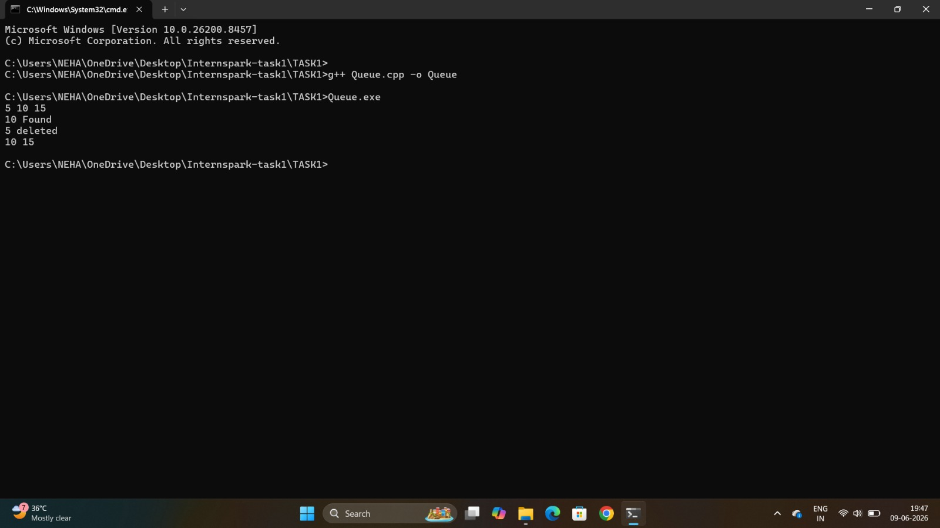
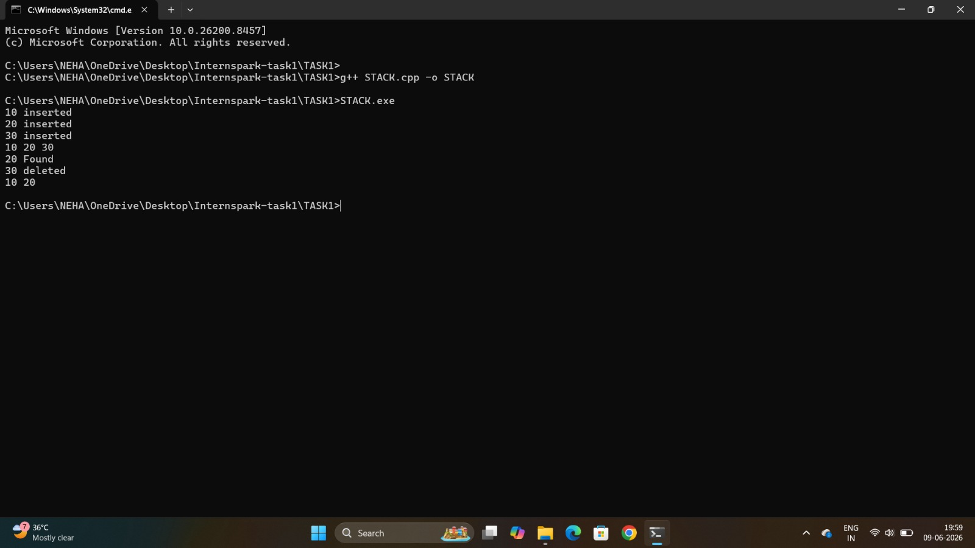
Conclusion
The objective of the task was successfully completed and tested.

